Python Workshop Series Final Project

**Part 0 – Random Number Generator with Memory**

This exercise is designed to test your grasp of core python.

*Hint: You will have to use some computer science theory, so think out of the box. My solution is less than 20 lines of code, for what it’s worth.*

Create a random number generator (RNG) that includes a memory so while the program is running, it shouldn’t generate a number it already generated before. Also include a method to clear the memory. If the range of numbers is satisfied then prompt the user that memory is full and it needs to be cleared before expecting any new random numbers.

This entire program should be encapsulated into a class. For the sake of simplicity make the program with RNG limits [3,8], and also make sure you automatically print all the results, as I will be running the program with a unit test script, so if it fails that test, it’s a failure. The test will expect 6 unique numbers followed by the string then a list with all the unique numbers then an empty list and a number to prove its empty. As shown in the picture below.

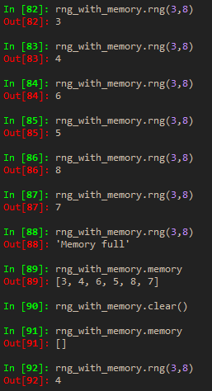

**Part 1 – Engineering application**

This exercise will test